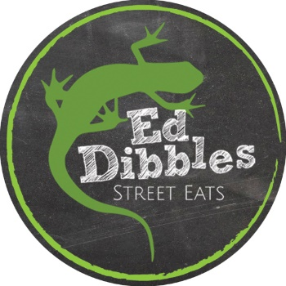
Beer & Wines List
March 2024

Gin Bar – (NOW OPEN – Enjoy because if you don’t, we will)
We have hand selected our favourite gins and tonic water or your enjoyment.
Hendricks Gin 25ml measure - Hendrick's is an infusion of rose petal and cucumber gin made as a delightful antidote to the ordinary – abv 41.4% 3.25
Mermaid Gin 25ml measure - Mermaid Gin is hand - crafted using ten ethically sourced botanicals. A smooth yet complex blend of fresh organic lemon zest. The peppery notes in grains of paradise and a hint of sea air from fragrant rock samphire – abv 42% 3.55
Tanqueray London Dry 25ml measure – Tanqueray is a perfectly balanced gin, with the ideal combination of classic gin botanicals. This best-selling gin was created by Charles Tanqueray in 1830 and is still made according to the original timeless recipe – abv 41.3% 2.85
Fever-Tree Light Premium Indian Tonic Water 150ml - A crisp & fresh tonic water crafted by blending spring water with subtle botanical flavours and quinine from the fever trees of East & Central Africa. 1.50
Beer, Lager & Cider – by the bottle
Shepherd & Neame Spitfire (Bitter) – abv 4.2% - 500ml 4.25
Marston’s Old Empire (IPA) – abv 5.7% – 500ml 4.75
Estrella Damm (Lager) – abv 4.6% - 660ml 4.95
Thatcher’s Gold (Cider) – abv 4.8% - 500ml 3.95
Henry Weston’s Vintage Medium (Cider) – abv 8.2% - 500ml 4.50

House Wines - single serve bottles
White wines:
Chardonnay (South Africa) abv 12.5% - 187ml 4.75
Sauvignon Blanc (Chile) abv 12.5% - 187ml 5.25
Pinot Grigio (South Africa) abv 12% - 187ml 4.75

Red wines:
Merlot (Chile) abv 12.5% - 187ml 4.75
Shiraz (Chile) abv 12.5% - 187ml 5.00

Rosé wine:
Zinfandel (California) abv 10.5%- 187ml 4.75
Sparkling Wine:
Prosecco Extra Dry (Italy) abv 11% - 200ml 5.90

