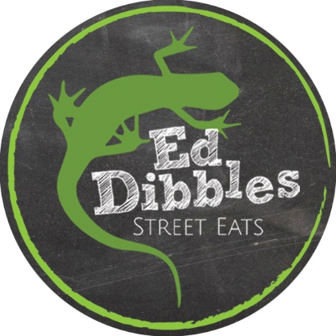
Ed Dibbles Food Menu
Please note all dishes are prepared to order therefore, we don’t do fast food, we do freshly prepared food as fast as we can. During our busy periods there may be a longer wait than usual. If this is the case, you will be informed prior to your order being taken.
Cutlery, napkins, salt, pepper, condiments & vinegar can be collected from the table by the main door

Breakfast from Wednesday to Friday - Items from 10.30am ~ 11.45am…
Breakfast from Saturday & Sunday - Items from 10.00am ~ 11.45am…

Prime back bacon in a buttered floured bap
- 3 x rashers Pritchett’s rindless back bacon 5.50
Gluten free local sausages in a buttered floured bap
– 2 x Pritchett’s cracked black pepper & herb sausage 5.50
- 2 x Richmond’s vegan sausage (not gluten free) 5.50
Free range eggs in a buttered floured bap
- 2 free range eggs – fried or scrambled 5.00
***New*** - “The Vegas Job”
– Pritchetts back bacon (2), Pritchetts cracked black pepper & herb gluten free sausage (2), free range scrambled egg (1) – with melted mature Cheddar cheese all served in a flour tortilla wrap 8.50

Extras:
A free range fried or scrambled egg to any of the above 1.25
A gluten free cracked black pepper & herb sausage to any of the above 1.00
A vegan sausage to any of the above 1.25
A portion of Heinz baked beans to any of the above 0.80

(Dairy free spread or GF bread available – please ask when ordering)

Ed Dibbles Food Menu
Please note all dishes are prepared to order therefore, we don’t do fast food, we do freshly prepared food as fast as we can. During our busy periods there may be a longer wait than usual. If this is the case, you will be informed prior to your order being taken.
Cutlery, napkins, salt, pepper, condiments & vinegar can be collected from the table by the main door.
Lunch Menu from Wednesday to Sunday
Items from 12 noon ~ 14.30…
Homemade Soup of the Day – A homemade made bowl of soup served with a ciabatta roll and butter 7.00
Grilled Sandwiches: (All available GF plus *DF cheese available, please ask)
All our grilled sandwiches are served with a mixed salad garnish and our house slaw (not Ve)
(V or VE) Gambetta – pesto, black olives, roasted peppers, sun-dried tomatoes, sliced red onion & mature Cheddar cheese 8.00
Coronation Chicken Melt – homemade Coronation chicken (chopped chicken breast, sultanas, apricots, spring onion, fresh coriander dressed in a curry mayo) & mature Cheddar cheese 8.50
Tuna & Sweetcorn Melt – tuna & sweetcorn mayonnaise, mature Cheddar cheese 8.25
Ham & Cheddar Cheese – Pritchett’s’ ham, mature Cheddar cheese & caramelised red onion chutney 8.00
(V) or (VE) Just Cheese – mature Cheddar cheese 7.50
(V) or (VE) Just Cheese – the full works – as above but with sliced tomato & sliced red onion 8.00
(V) Korean Kim – mature Cheddar cheese and homemade house kimchi 7.75
*Vegan Cheese options will incur an extra charge due to raw produce cost 0.25
Jacket Potatoes (All GF):
All our jackets are served with a mixed salad garnish, our house slaw (not Ve) , and 2x pats of butter
Homemade Coronation Chicken 8.75
Tuna & Sweetcorn (optional sliced red onion) 8.75
Homemade Chilli Con Carne – with 2 secret ingredients!! 8.75
(VE) Homemade Chilli non-Carne (3 bean chilli plus sweetcorn) 8.50
(V) Korean Kimchi – homemade and fermented on site 8.50
(VE) Baked Beans 7.75
(V) Add grated cheese to any jacket 1.00
(VE) Add vegan cheese to any jacket 1.25
Extras:
(V) Add a bowl of skin-on fries to any main meal – please note we DO NOT serve a bowl of fries on their own, they must be ordered with any main meal. (GF but not suitable for coeliacs) 3.75

